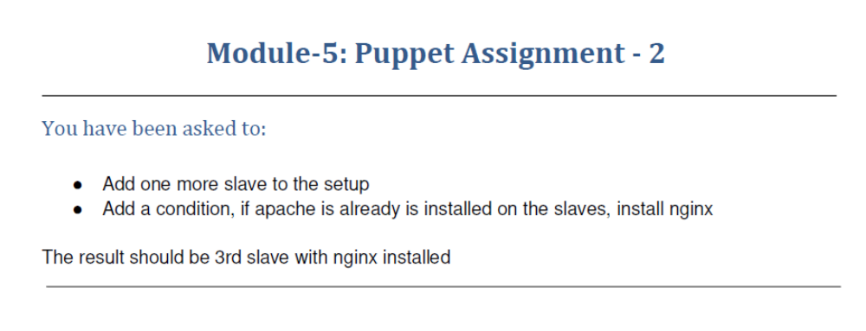
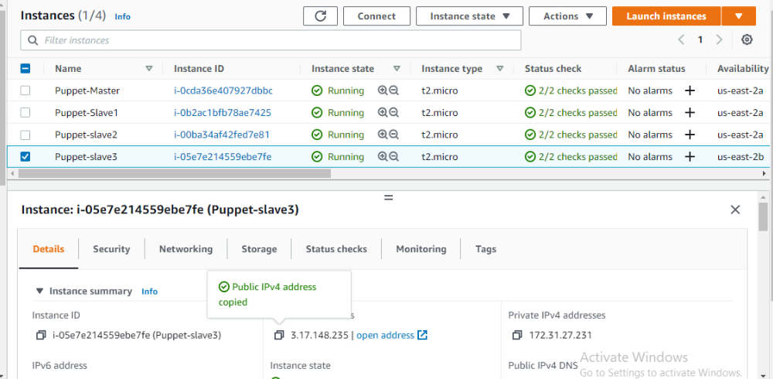

ubuntu@ip-172-31-27-231:~$ sudo puppet agent --test
/usr/lib/ruby/vendor_ruby/puppet/util.rb:461: warning: URI.escape is obsolete
/usr/lib/ruby/vendor_ruby/puppet/util.rb:461: warning: URI.escape is obsolete
/usr/lib/ruby/vendor_ruby/puppet/util.rb:461: warning: URI.escape is obsolete
/usr/lib/ruby/vendor_ruby/puppet/util.rb:461: warning: URI.escape is obsolete
/usr/lib/ruby/vendor_ruby/puppet/util.rb:315: warning: deprecated Object#=~ is called on Puppet::Transaction::Report; it always returns nil
/usr/lib/ruby/vendor_ruby/puppet/util.rb:461: warning: URI.escape is obsolete
/usr/lib/ruby/vendor_ruby/puppet/util.rb:461: warning: URI.escape is obsolete
/usr/lib/ruby/vendor_ruby/puppet/util.rb:461: warning: URI.escape is obsolete
/usr/lib/ruby/vendor_ruby/puppet/util.rb:315: warning: deprecated Object#=~ is called on Puppet::Transaction::Report; it always returns nil
/usr/lib/ruby/vendor_ruby/puppet/util.rb:461: warning: URI.escape is obsolete
Info: Using configured environment 'production'
Info: Retrieving pluginfacts
/usr/lib/ruby/vendor_ruby/puppet/util.rb:461: warning: URI.escape is obsolete
/usr/lib/ruby/vendor_ruby/puppet/util.rb:315: warning: deprecated Object#=~ is called on Puppet::Transaction::Report; it always returns nil
/usr/lib/ruby/vendor_ruby/puppet/util.rb:461: warning: URI.escape is obsolete
/usr/lib/ruby/vendor_ruby/puppet/indirector/request.rb:272: warning: URI.unescape is obsolete
/usr/lib/ruby/vendor_ruby/puppet/util.rb:461: warning: URI.escape is obsolete
Info: Retrieving plugin
/usr/lib/ruby/vendor_ruby/puppet/util.rb:461: warning: URI.escape is obsolete
/usr/lib/ruby/vendor_ruby/puppet/util.rb:315: warning: deprecated Object#=~ is called on Puppet::Transaction::Report; it always returns nil
/usr/lib/ruby/vendor_ruby/puppet/util.rb:461: warning: URI.escape is obsolete
/usr/lib/ruby/vendor_ruby/puppet/indirector/request.rb:272: warning: URI.unescape is obsolete
/usr/lib/ruby/vendor_ruby/puppet/util.rb:461: warning: URI.escape is obsolete
Info: Retrieving locales
/usr/lib/ruby/vendor_ruby/puppet/util.rb:461: warning: URI.escape is obsolete
/usr/lib/ruby/vendor_ruby/puppet/util.rb:315: warning: deprecated Object#=~ is called on Puppet::Transaction::Report; it always returns nil
/usr/lib/ruby/vendor_ruby/puppet/util.rb:461: warning: URI.escape is obsolete
/usr/lib/ruby/vendor_ruby/puppet/indirector/request.rb:272: warning: URI.unescape is obsolete
/usr/lib/ruby/vendor_ruby/puppet/util.rb:461: warning: URI.escape is obsolete
/usr/lib/ruby/vendor_ruby/puppet/util.rb:461: warning: URI.escape is obsolete
Info: Caching catalog for ip-172-31-27-231.us-east-2.compute.internal
/usr/lib/ruby/vendor_ruby/puppet/file_system/uniquefile.rb:126: warning: $SAFE will become a normal global variable in Ruby 3.0
/usr/lib/ruby/vendor_ruby/puppet/util.rb:461: warning: URI.escape is obsolete
/usr/lib/ruby/vendor_ruby/puppet/util.rb:461: warning: URI.escape is obsolete
/usr/lib/ruby/vendor_ruby/puppet/util.rb:461: warning: URI.escape is obsolete
Info: Applying configuration version '1638814218'
Notice: /Stage[main]/Main/Node[default]/Package[nginx]/ensure: created
/usr/lib/ruby/vendor_ruby/puppet/file_system/uniquefile.rb:126: warning: $SAFE will become a normal global variable in Ruby 3.0
Notice: /Stage[main]/Main/Node[default]/File[/tmp/status.txt]/ensure: defined content as '{md5}33953125d5378c23cb0a98b5e2efe1d0'
/usr/lib/ruby/vendor_ruby/puppet/file_system/uniquefile.rb:126: warning: $SAFE will become a normal global variable in Ruby 3.0
/usr/lib/ruby/vendor_ruby/puppet/file_system/uniquefile.rb:126: warning: $SAFE will become a normal global variable in Ruby 3.0
Notice: Applied catalog in 6.84 seconds
/usr/lib/ruby/vendor_ruby/puppet/file_system/uniquefile.rb:126: warning: $SAFE will become a normal global variable in Ruby 3.0
/usr/lib/ruby/vendor_ruby/puppet/util.rb:461: warning: URI.escape is obsolete
/usr/lib/ruby/vendor_ruby/puppet/file_system/uniquefile.rb:126: warning: $SAFE will become a normal global variable in Ruby 3.0
ubuntu@ip-172-31-27-231:~$

